Westpac JavaScript Coding Exercise

Introduction
Described below is a short coding exercise we use to demonstrate a candidate’s knowledge of JavaScript programming and their ability to produce clean efficient code. We expect candidates to spend no more than an hour on the exercise, so are not expecting production ready code. However we would like candidates to point out any assumptions they have made and limitations of their implementation.

Exercise details
Candidates are required to develop a jQuery scrollable table plugin that can display hundreds of thousands of rows. The plugin should not cause significant rendering delays either during initial load, or scrolling.
We have provided some sample data, css and index.html. Please update script.js with your plugin implementation.

Plugin specification

Options

Name | Type | Default Value | Description
items | Array | [] | A list of data items to be loaded to the table
rowHeight | Number | 20 (pixels) | The height of each row of the table

Events

buildRow(rowElement, rowIndex)
Triggered when each row element is created, should be overridden to customize the row element, e.g. adding classes or appending sub-elements
- rowElement:
Type: DOM element of the row
- rowIndex:
The index of the row being created, starting from 0.

Example usage

var list = [];
for(var i = 1; i <= 1000000; i ++){
list.push('line ' + i);
}
$('#container').fastTable({
items: list,
rowHeight: 20,
buildRow: function (rowElem, rowIdx) {
var $elem = $(rowElem),
elemText = list[rowIdx];
$elem.append('<div>' + elemText + '</div>');
if (rowIdx % 2 != 0) $elem.addClass("odd");
}
});

Given the code snippet above, the result should be something like below:
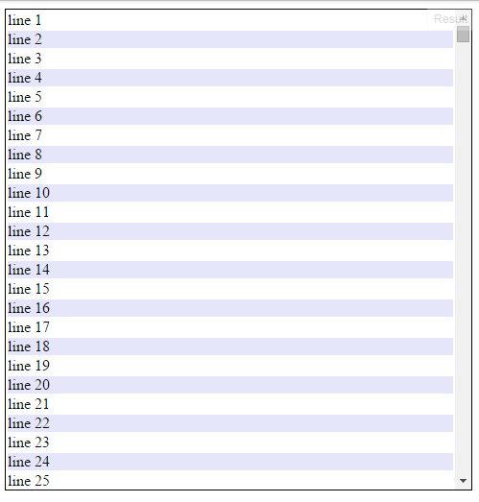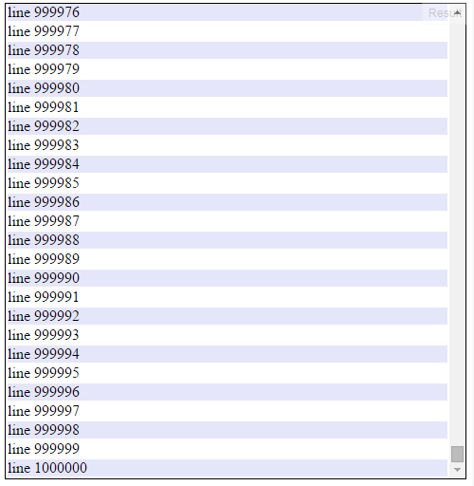

Angular variation
If the candidate wishes to, they are welcome to produce an equivalent Angular directive instead of a JQuery plugin.

